**Chapter 1**

**Introduction**

**1.1 Overview**

Digital Twins integrate internet of things, artificial intelligence, machine learning and software analytics to create spatial network graph, living digital simulation models that update and change as their physical counterpart change. They are used for enhancing performance and reducing operating cost, offer the business including increased reliability of equipment and production lines.

The widespread use of digital twins holds the promise to increase operational efficiency, allow for resource optimisation, improve asset management, deliver cost savings, improve productivity and safety. The digitisation of the built environment, enabled by an increase in computing power, cheaper sensors, Internet of Things (IoT), advanced analytics and greater sophistication of 3D visualisation and immersive environments, therefore has the potential to actively contribute towards achieving the UN Sustainable Development Goals (SDGs)

**1.2 What is Digital Twin?**

* Digital twins are virtual replicas of physical devices that data scientists and IT professionals can use to run simulations before actual devices are built and deployed.
* They are used for enhancing performance, reduce the operational cost, offer the business including increased reliability of equipment and pipelines.
* It continuously learns from sensor data and conveys various aspects of operating conditions.

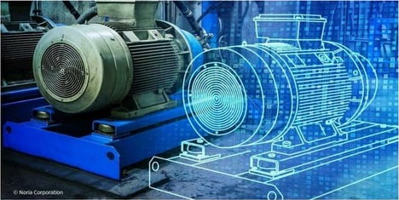

**Fig 1.1:** Digital Twin

**1.3 Concept and a brief history of digital twin.**

**1.3.1 Concept.**

The first appearance of the DT dates to 2003, when Grieves introduced the concept, for the first time, in his course on “product lifecycle management”. Although the concept was insufficiently specific at that time, a preliminary form of the DT was proposed to include three parts: physical product, virtual product, and their connections. The enabling technologies of DTs experienced exponential growth since then. In 2012, the concept of DTs was revisited by the National Aeronautics and Space Administration (NASA), which defined the DT as a multi physics, multiscale, probabilistic, ultra fidelity simulation that reflects, in a timely manner, the state of a corresponding twin based on the historical data, real-time sensor data, and physical model. DTs become a popular research topic.

According to Maurer, the DT is a digital representation that can depict the production process and product performance. The meaning of DTs becomes increasingly concrete since then, leading to some special notions such as the airframe digital twin (ADT) and experimental digital twin (EDT). There are different understandings of DTs. Some researchers believe that the DT research should focus on simulation. Others argue that the DT contains three dimensions: physical, virtual, and connection parts. Fig. 1 illustrates the basic framework, in which, the virtual space is mapped to the physical space through the connection part that exchanges data and information. On the basis of the three-dimension model for the DT, Tao et al. proposed that a complete DT should include five dimensions: physical part, virtual part, connection, data, and service.

The framework is, where PE represents the physical entity; VE represents the virtual entity; Ss represents the services for both PE and VE; DD stands for the DT data; and CN means the connection of different parts. The five dimensions are equally important for DTs. The physical part is the basis of building the virtual part. The virtual part supports the simulation, decision making, and control of the physical part. Data lie in the canter of DTs, because it is a precondition for creating new knowledge. Furthermore, DTs lead to new services that can enhance the convenience, reliability, and productivity of an engineered system. Finally, the connection part bridges the physical part, virtual part, data, and service.

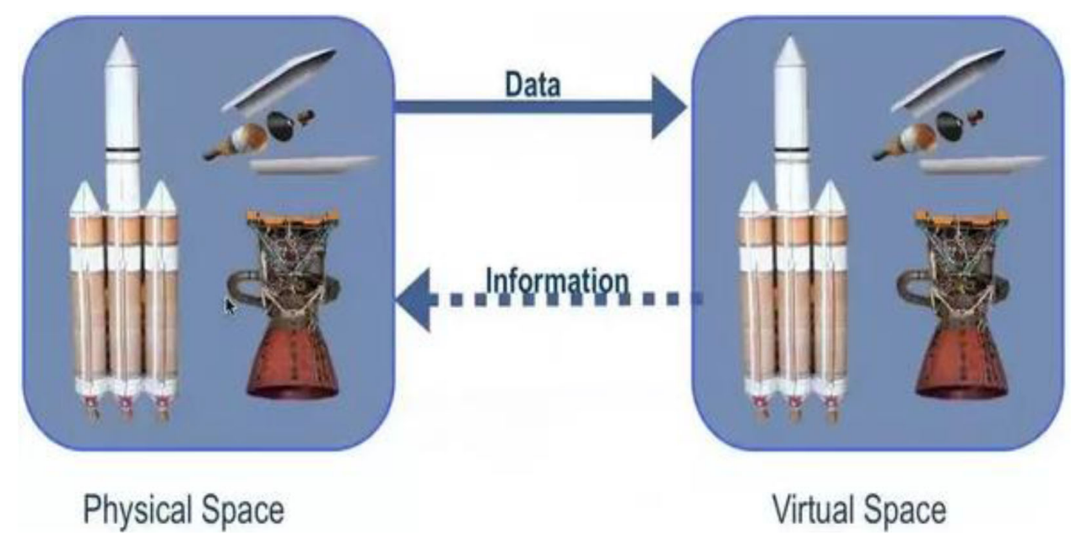

**Fig 1.2:** Three-dimension model for the DT

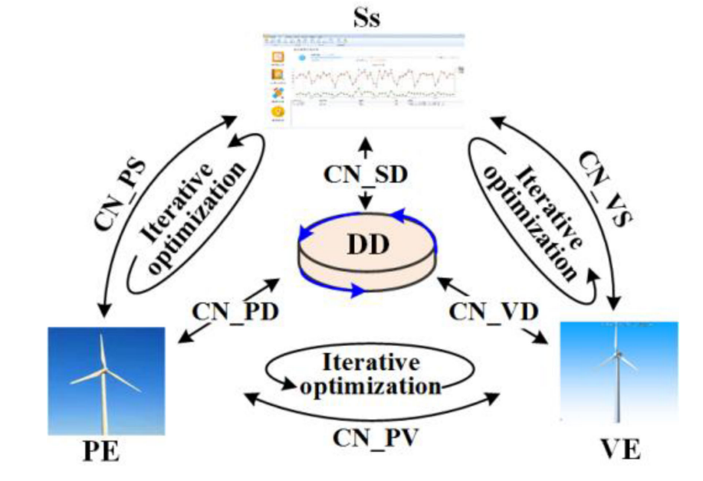

**Fig 1.3:** Five Dimensional DT

**1.3.2 History**

After the launch of Apollo 13 on April 1970, no one could have predicted it would become a fight for survival as the oxygen tanks exploded early into the mission. It became a famous rescue mission as the world held its breath, with technical issues needing to be resolved from up to 200,000 miles away. A key to the rescue mission, however, was that NASA had a digital twin model of Apollo 13 on earth which allowed engineers to test possible solutions from ground level. Of course, systems have now become predominantly virtual rather than physical simulations. With the concept already being practiced for a few decades, the phrase ‘digital twin’ was first mentioned in 1998 and was being referred to a digital copy of actor Alan Alda’s voice in Alan Alda meets Alan Alda 2.0. Although the digital twins have been highly familiar since 2002, only as recently as 2017 has it become one of the top strategic technology trends. The Internet of Things enabled digital twins to become cost-effective so they could become as imperative to business as they are today

The digital twin concept gained recognition in 2002 after Challenge Advisory has hosted a presentation for Michael Grieves in the University of Michigan on technology. The presentation involved the development of a product lifecycle management center. It contained all the elements familiar with the digital twin including real space, virtual space and the spreading of data and information flow between real and virtual space. While the terminology may have changed over the years the concept of creating a digital and physical twin as one entity has remained the same since its emergence.

**1.4 Characteristics of Digital Twin Technology.**

The main characteristics of digital twin are:

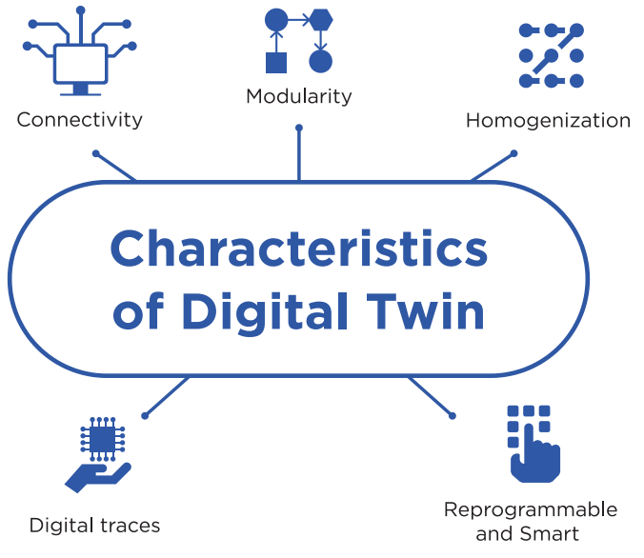

**Fig 1.4:** Characteristics of Digital Twin

**Connectivity:** A digital twin is based on connectivity. It enables connection between the physical element and its digital counterpart. The sensors create the connectivity of physical products that obtain, integrate and communicate data using various integration technologies.

**Homogenization:** Digital twins are both the consequence and enabler of homogenization of data. It allows the decoupling of information from its physical form.

**Reprogrammable and Smart:** Digital twins automatically enable reprogrammability through sensors, artificial intelligence techniques and predictive analysis.

**Digital traces**: Digital twin technologies leave digital traces. The trails are helpful to diagnose the source of the problem that occurred in case of machine malfunctions.

**Modularity:** Modularity is referred to the design and customization of products and production modules. The addition of modularity to functional models helps manufacturers gain the ability to tweak machines and models.

## **1.5 What Challenges has it Solved?**

Since it can be used across a wide range of industries, from automotive to healthcare and power generation, it has already been used to solve a large number of challenges. These challenges include [fatigue testing](https://www.twi-global.com/technical-knowledge/job-knowledge/fatigue-testing-078) and corrosion resistance for offshore wind turbines and efficiency improvements in racing cars. Other applications have included the modelling of hospitals to determine work flows and staffing to find procedure improvements.

A digital twin allows users to investigate solutions for product lifecycle extension, manufacturing and process improvements, and product development and prototype testing. In such cases, a digital twin can virtually represent a problem so that a solution can be devised and tested in the program rather than in the real world.

# **1. 6 UNDERLYING TECHNOLOGIES**

## **1.6.1 Internet of Things**

The Internet Of Things is the term given to devices connected to the internet. It is about giving so-called "things" a sense Of intelligence and the ability to collect information on their environment. The idea that all devices that are interconnected gives the developer the ability to track and monitor everything we do, thus leading to a smarter world. The number Of IOT devices recorded year on year shows the considerable growth Of this technology.

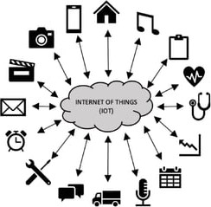

**Fig 1.5:** Underlying Technologies

**1.6.2 Data Analytics**

The term data analytics stems from the field of Data Science", a multidisciplinary subject that covers a range of concepts, with an emphasis on collecting and presenting data for analysis to gain greater insight. To perform data analysis, the need for raw data is paramount. There are several actions needed to turn this data into usable information, ready for use in algorithms and statistical analysis. These being the requirements, collection, processing and cleaning. The requirements set Out the necessary needs of the data and how it is used, ensuring that specific requirements are outlined, considering the intended use of the data. The second stage acts on the requirement of collecting the relevant data, identifying physically where and how the data

Will be collected. The collected data Will then go through a processing phase in which it is sorted according to specific requirements Despite the data being collected and sorted, it may have significant gaps or erroneous data.. The requirements set Out the necessary needs of the data and how it is used, ensuring that specific requirements are outlined, considering the intended use of the data.

**1.6.3 Statistics**

Statistics is the overarching term for the collection, classification, analysis, and interpretation of data. Briefly relevant in this case for data analysis as statistical models underpin machine learning algorithms. Statically inference and descriptive statistics are another way in which data analytics are used to describe observations in collected data. Al and the following topics below show the growth Of advanced data analytics

**1.6.4 Artificial intelligence**

Artificial intelligence (Al) is a wide ranging brunch of computer science concerned With building smart machines capable Of performing tasks that typically require human intelligence. Al is an interdisciplinary science With multiple approaches, but advancements in machine learning and deep learning are creating a shift in virtually every sector of the tech industry. Al programming focuses on three cognitive skills: learning, reasoning and self- correction.

**1.6.5 Machine Learning**

A subsection of Al, machine learning is the creation Of algorithms that can give the Computer the ability to learn and act for the user without being directly programmed to do so. Machine learning is used to create programmes that use sophisticated algorithms to collect and analyze data autonomously. For more general analysis, machine learning can fit into two types Of learning•.

1. **Supervised Learning** This is the most popular form Of machine learning. The algorithms use large amounts of labelled data to analyze and learn. The algorithm is tasked with learning and analyzing the labelled data to identify a given task correctly; image classification is one example. The algorithms learn from training data and are then given test data to see how well it is accurately predicting What an image is showing, presented through an accuracy percentage. The user then analyses these answers and any errors are corrected and re-learned, helping train the model and increasing the accuracy ofa given algorithm
2. **Unsupervised Learning** Unsupervised learning is another form of machine learning, it does not require expensively marked-up data where for each input pattern the desired output has previously been determined: as is required for supervised learning Unsupervised learning algorithms learn using its own methods in categorizing and highlighting patterns within data instead of relying on user feedback. Clustering is one method of categorizing data. Algorithms learn to cluster unlabeled data sets together, potentially showing hidden patterns that were not explicitly identifiable

**1.6.6 Deep Learning**

Deep learning is another part of the field of data analytics and a subsection of machine learning. Deep learning algorithms learn unstructured and unlabel data using complex neural networks With autonomous input feature extraction as opposed to manual extraction. These networks utilize machine learning to create deep learning models that can take longer to train because of the much larger neural networks, but this allows for greater accuracy. Another type of learning is semi supervised learning, defined as having some labelled data, but more data is un labeled to see how the algorithms can leant to be more accurate. Many more algorithms appear throughout the field Of data science, but these are the most

**1.6.7 Data Visualization**

The final subtopic within data analytics is visual union, defined as a graphical representation or visualization Of data or results. The type Of data affects the way it is visualized. The most common being multidimensional data, Which can be presented using graphs and charts, taking multiple variables. for instance, bar or pie charts. Another data type is geospatial; this involves data collected from the earth through location data, visualized through distribution maps, cluster maps and more commonly, contour maps.

**1.6.8 Cloud computing**

Simply put, cloud computing is the delivery Of computing services—including servers, storage, databases, networking, software, analytics, and intelligence—over the Internet ("the cloud") to offer faster innovation. flexible resources. and economies of scale. You typically pay only for cloud services you use, helping lower your operating costs, run your infrastructure more efficiently and scale as your business need changes.

**1.6.9 API and open standards**

An open API (open referred to as a public API) is a publicly available application programming interface that provides developers With programmatic access to a proprietary software application or web service. APIs are sets Of requirements that govern how One application can communicate and interact with another.

**1.6.10 virtual reality**

Virtual reality (VR) is a simulated experience that can be similar to or completely different from the real world. Applications Of virtual reality include entertainment (e.g., video games), education (e.g., medical or military training) and business (e.g., virtual meetings). Other distinct types of VR style technology include augmented reality and mixed reality, sometimes referred to as extended reality or XR.

**Chapter 2**

**Digital Twin architecture, creation and working**

**2.1 Architecture**

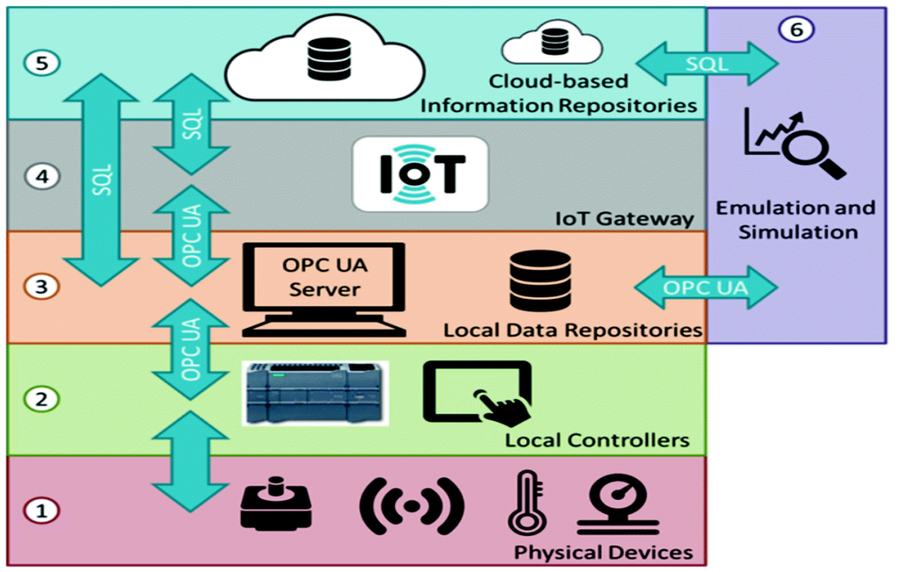

**Fig 2.1:** Architecture of Digital Twin

As in the above architecture generally six stages are involved in the digital twin architecture namely physical devices, local controllers, local data repositories, IOT gateway, cloudbased information repositories, emulation and simulation. The stages are explained in detail below

**1.Physical devices**

Devices such as sensors, routers which is source of our data.

**2.Local controllers**

Local controllers control the data locally either manually or through some specified devices according to our need as show in above figure

**3.Local data repositories**

Depending on amounts of data we choose our local storage accordingly such as databases, data warehouses etc. OPCUA Sever is use for machine-to-machine communication

**4.IOT gateway**

IOT gateway plays an important role in digital twin architecture as it is where the actual communication is established between local repositories and cloud-based repositories. **5.Cloud-based repositories**

The data obtained from sensors stored in the local system will be loaded into clod repositories using IOT gateway, OPCUA server which will be used for further processing by cloud-base system.

**6.Emulation and Simulation**

This stage involves developing virtual twin which is main task involved in the architecture. Emulation generally shows the output. Simulation shows the output virtually.

**2.2 How to create Digital twin?**

**Digital twin process design and information requirements**

The digital twin creation starts with process design. What are the processes and integration points for which the twin will be modeling? Standard process design techniques should be used to show how business processes, people enabling the processes, business applications, information, and physical assets interact. Diagrams are created that link the process flow to the applications, data needs, and the types of sensor information required to create the digital twin. The process design is augmented with attributes where cost, time, or asset efficiency could be improved. These typically form the base line assumptions from which the digital twin enhancements should begin.

Digital twin conceptual architecture The digital twin conceptual architecture (figure 2) can rightly be thought of as an expansive or “under the hood” look at the enabling components that comprise the manufacturing process digital twin model of figure 1, although the same basic principles may likely apply in any digital twin configuration. The conceptual architecture may be best understood as a sequence of six steps, as follows:

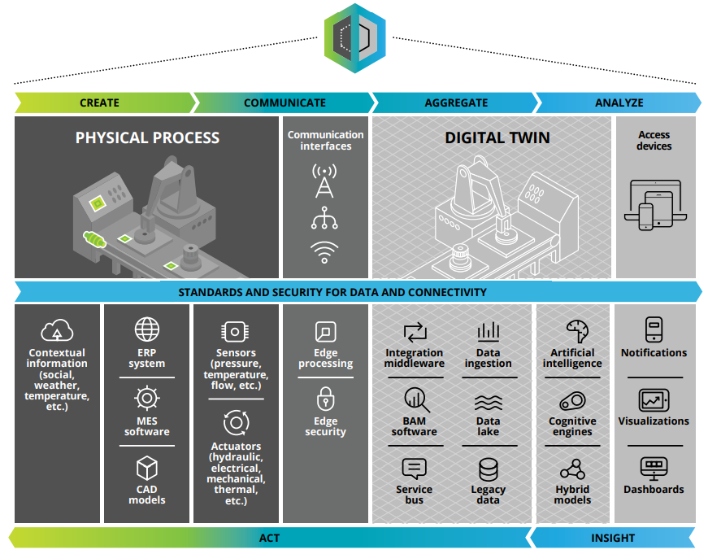

**Fig 2.2**: Digital twin conceptual architecture

**Create:**

The create step encompasses outfitting the physical process with myriad sensors that measure critical inputs from the physical process and its surroundings. The measurements by the sensors can be broadly classified into two categories: (1) operational measurements pertaining to the physical performance criteria of the productive asset (including multiple works in progress), such as tensile strength, displacement, torque, and color uniformity; (2) environmental or external data affecting the operations of a physical asset, such as ambient temperature, barometric pressure, and moisture level. The measurements can be transformed into secured digital messages using encoders and then transmitted to the digital twin.

**Communicate**:

The communicate step helps the seamless, real-time, bidirectional integration/connectivity between the physical process and the digital platform. Network communication is one of the

radical changes that have enabled the digital twin; it comprises three primary components:

* . Edge processing: The edge interface connects sensors and process historians, processes signals and data from them near the source, and passes data along to the platform. This serves to translate proprietary protocols to more easily understood data formats as well as reduce network communication. Major advances in this area have eliminated many bottlenecks that have limited the viability of a digital twin in the past.
* Communication interfaces: Communication interfaces help transfer information from the sensor function to the integration function. Many options are needed in this area, given that the sensor producing the insight can, in theory, be placed at almost any location, depending on the digital twin configuration under consideration: inside a factory, in a home, in a mining operation, or in a parking lot, among myriad other locations.
* Edge security: New sensor and communication capabilities have created new security issues, which are still developing. The most common security approaches are to use firewalls, application keys, encryption, and device certificates. The need for new solutions to safely enable digital twins will likely become more pressing as more and more assets become IP enabled.

**Aggregate:**

The aggregate step can support data ingestion into a data repository, processed and prepared for analytics. The data aggregation and processing may be done either on the premises or in the cloud. The technology domains that power data aggregation and processing have evolved tremendously over the last few years in ways that allow designers to create massively scalable architectures with greater agility and at a fraction of the cost in the past.

**Analyze:**

In the analyze step, data is analyzed and visualized. Data scientists and analysts can utilize advanced analytics platforms and technologies to develop iterative models that generate insights and recommendations and guide decision making. Therefore, an approach that is either too simplistic or too complex could kill the momentum to move forward offers a possible approach that falls somewhere in between.

**Insight:** In the insight step, insights from the analytics are presented through dashboards with visualizations, highlighting unacceptable differences in the performance of the digital twin model and the physical world analogue in one or more dimensions, indicating areas that potentially need investigation and change.

**Act**:

The act step is where actionable insights from the previous steps can be fed back to the physical asset and digital process to achieve the impact of the digital twin. Insights pass through decoders and are then fed into the actuators on the asset process, which are responsible for movement or control mechanisms, or are updated in back-end systems that control supply chains and ordering behavior—all subject to human intervention.17 This interaction completes the closed loop connection between the physical world and the digital twin.

The computation power of big data engines, the versatility of the analytics technologies, the massive and flexible storage possibilities of the aggregation area, and integration with canonical data allow the digital twin to model a much richer, less isolated environment than ever before.. It is important to note that the above conceptual architecture should be designed for flexibility and scalability in terms of analytics, processing, the number of sensors and messages, etc. This can allow the architecture to evolve rapidly with the continual, and sometimes exponential, changes in the market.

**2.3 How to get started?**

**G**iven the wide applications of the digital twin, how does one get started? A major challenge in undertaking a digital twin process can reside in determining the optimal level of detail in creating a digital twin model. While an overly simplistic model may not yield the value a digital twin promises, taking too fast and broad an approach can almost guarantee getting lost in the complexity of millions of sensors, hundreds of millions of signals the sensors produce, and the massive amount of technology to make sense of the model. Therefore, an approach that is either too simplistic or too complex could kill the momentum to move forward offers a possible approach that falls somewhere in between.

Imagine the possibilities. The first step would be to imagine and shortlist a set of scenarios that could benefit from having a digital twin. The right scenario may be different for every organization and circumstance, but will likely have the following two key characteristics:

1. The product or manufacturing process being considered is valuable enough for the enterprise to invest in building a digital twin.

2. There are outstanding, unexplained processor product-related issues that could potentially unlock value either for the customers or the enterprise.

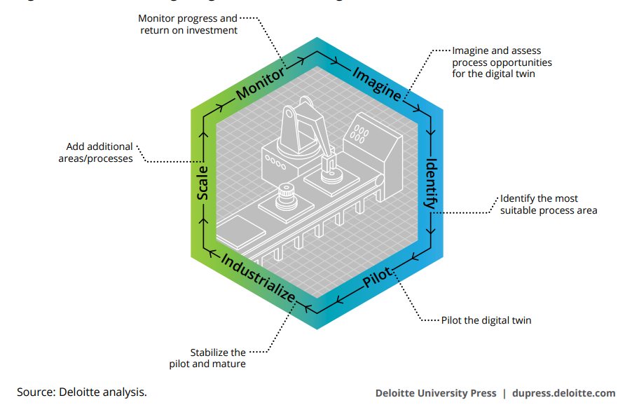

**Fig 2.3:** Start of Digital Twin

After the shortlist of scenarios is created, each scenario would be assessed to identify pieces of the process that can provide quick wins by using a digital twin. We encourage a focused ideation session with members of operational, business, and technical leadership for expediting the assessment.

**Identify the process**

The next step would be to identify the pilot digital twin configuration that is both of the highest possible value and has the best chance of being successful. Consider operational, business, and organizational change management factors in identifying which configurations could be best candidates for the pilot. Focus on areas that have potential to scale across equipment, sites, or technologies. Companies may face challenges going too deep into a specific digital twin of a highly complex equipment or manufacturing process, while the ability to deploy broadly across the organization tends to drive the most value and support: Focus on going broad rather than deep.

**Pilot a program**

Consider moving quickly into a pilot program using iterative and agile cycles to accelerate learning, manage risk proactively, and maximize return on initial investments. The pilot can be a subset of business divisions, or products to limit scope, but with the ability to show value to the enterprise. As you move through the pilot, the implementation team should support adaptability and an open mind-set—at any time of your journey, maintain an open and agnostic ecosystem that would allow adaptability and integration with new data (structured and unstructured) and leverage new technologies or partners. While you should want to be agnostic to any type of data sources (for example, new sensors and external data sources), you also need a solution that can support the expansion of an end-to-end solution (from early development to after sales). As soon as the initial value is delivered, consider building on this momentum to continue the drive for greater results. Communicate the value realized to the larger enterprise.

**Industrialize the process**

Once success is shown in the field, you can industrialize the digital twin development and deployment process using established tools, techniques, and playbooks. Manage expectations from the pilot team and other projects seeking to adopt it. Develop insights on the digital twin process and publish to the larger enterprise. This may include moving from a more siloed implementation to integration into the enterprise, implementation of a data lake, performance and throughput enhancements, improved governance and data standards, and implementation of organizational changes to support the digital twin.

**Scale the twin**

Once successful, it can be important to identify opportunities to scale the digital twin. Target adjacent processes and processes that have interconnections with the pilot. Use the lessons learned from the pilot and the tools, techniques, and playbooks developed during the pilot to scale expeditiously. As you scale, continue to communicate the value realized through the adoption of the digital twin by the larger enterprise and shareholders.

**Monitor and measure**

Solutions should be monitored to objectively measure the value delivered through the digital twin. Identify whether there were tangible benefits in cycle time, yield throughput, quality, utilization, incidents, and cost per item, among others. Make changes to digital twin processes iteratively, and observe results to identify the best possible configuration. Develop insights on the digital twin process and publish to the larger enterprise

All in all, true success in achieving early milestones on a digital twin journey will likely rely on an ability to grow and sustain the digital twin initiative in a fashion that can demonstrate increasing value for the enterprise over time. To help ensure such an outcome, one may need to integrate digital technologies and the digital twin into the complete organizational structure—from R&D to sales—continuously leveraging digital twin insights to change how the company conducts business, makes decisions, and creates new revenue streams.

AWS IoT Core and Microsoft Azure IoT are the next-generation IoT platforms that model the real world into the digital world. Azure Digital Twins is an IoT platform that helps create a digital representation of real-world objects, business processes, places, etc. It also helps to gain insights to drive products better, optimize operations and costs and provide enhanced customer experience.

**2.4 Approach**

**1. Acquire Data:**

It is the Physics based modelling where the real asset is converted to virtual body by the data from sensors.

**2. Data driven modelling:**

It is the part of machine learning where it develops the prediction model and detect the faults from the virtual body.

**3.Deploy**

It trains the model and become efficient

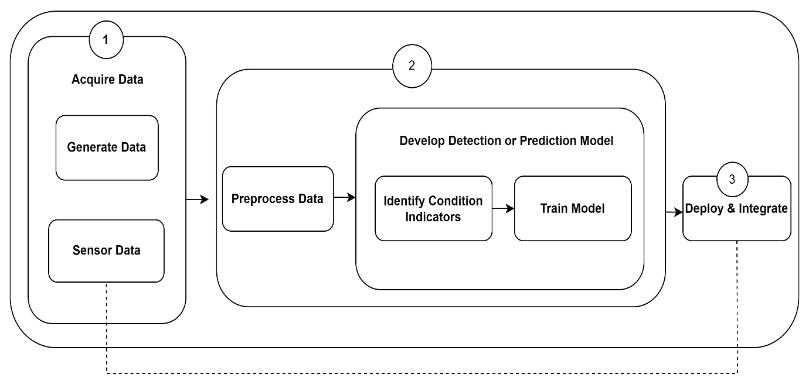

**Fig 2.4:** Approach

Capture Physics Captures behaviour using sensors

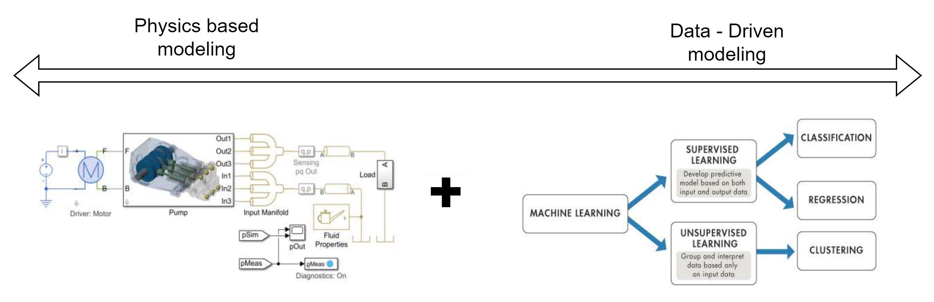

**Fig 2.5:** Physics and Data Driven model

**2.5 Overview of Digital twin that how it operates**

**A digital twin is an up-to-date representation of a real asset in operation.**

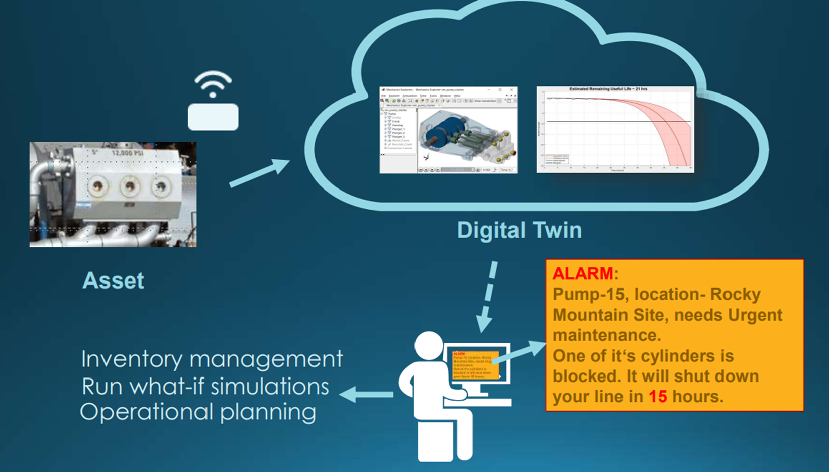

**2.6 Use Case - Fault classification of a pump**

**Objective:**

* Using machine data to determine what needs to be fixed

**Solution:**

* Develop predictive Maintenance Algorithm

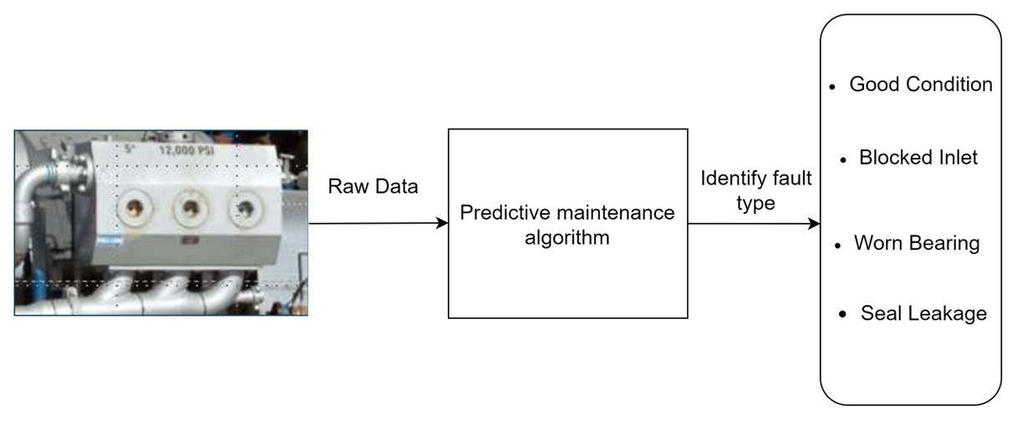

**Fig 2.6:** Fault detection of pump

**2.7 ALGORITHM**

* Digital twin technology is the development of advanced ML algorithms **deep neural network** that can be readily used to update the model and make future predictions
* **Derivative generalization method**
* **Principal Component Analysis (PCA)** In the context of Machine Learning (ML), PCA is an unsupervised machine learning algorithm that is used for dimensionality reduction.

**2.8 Working of Digital Twin**

**Step-1:**

First smart components that use sensors to gather data about real-time status, the working condition of the digital twin are integrated with a physical item. Sensors compatible with devices must be used to prevent any data loss.

**Step-2:**

The components are connected to a cloud-base system that receives and processes all the data that sensors monitor. Major task involved is done in the cloud-base system which must be efficient so that it can handle huge amounts of data coming from sensors and process them according.

**Step 3:**

This input is analysed against business and other contextual data. Analysis is done here from the output obtained from the previous step where data is processed against the needs which is analysed based on the requirements.

**Step 4:**

Lessons are learned and are uncovered within the virtual environment that can be applied to the physical world and used accordingly. Feedback is obtained in the previous step plays a most important role in improving the performance.

**Chapter 3**

**Types and applications of Digital Twin**

**3.1 TYPES OF DIGITAL TWIN**

There are a few variations on the types of digital twin that successfully employ digital twin technology. Although some are relatively dated, others are very pertinent.

**3.1.1 Digital Twin Prototype**

It describes the prototypical physical artifact. It contains the informational sets necessary to describe and produce a physical version that duplicates or twins the virtual version.

Throw some sensors on a product and wire that to some kind of embedded system, then wire that to your antenna and start sending data to an IoT platform. We run into limitations on the experiments you can conduct with physical prototypes. Swapping out a sensor isn’t easy when it’s soldered in place. We may run into electromagnetic interference for the antenna.

**3.1.2 Digital Twin Instance**

This type of Digital Twin describes a specific corresponding physical product. An individual Digital Twin remains linked to the product throughout the life of that physical product. Depending on the use cases required for it, this type of Digital Twin may contain the following components.

A fully annotated 3D model that describes the geometry of the physical instance and it’s components. A Bill of Materials that lists current and past components. A Bill of Process that lists the operations and results of any measurements and tests. A Service Record that describes past services, components replaced and operational States.

**3.1.3 Digital Twin Aggregate**

This type of digital twin is aggregation of digital twin instances. Unlike the DTI, the DTA may not be an independent data structure. It may be a computing construct that has access to all DTIs. It queries DTIs either ad-hoc or proactively. Proactively, the DTA might continually examine sensor readings. It correlates those sensor readings with failures to enable prognostics.

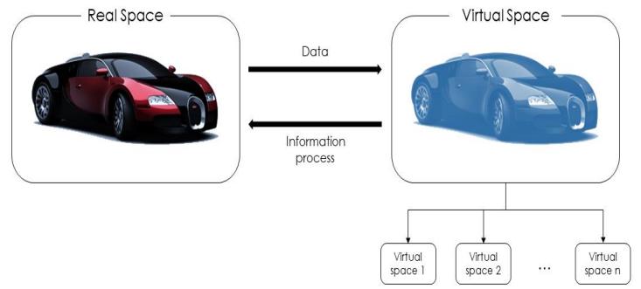

**Fig 3.1:** Types of Digital Twin

**3.2 Applications of Digital twin**

Digital twin technology is used in many applications such as Customer experience, Performance tuning, Digital machine building, Smart cities, Healthcare, Maintenance to improve the productivity, customer experience of the product by giving the virtual experience of the product in the initial stages before the actual launch of product and improving the performance of the product according to the needs and requirements of the customer.

**3.2.1 Automotive**

Digital twins are highly used for creating virtual models of connected vehicles. Automotive companies simulate and analyze the production phase to identify the potential problems during production or when the car hits the roads.

**3.2.2 Performance tuning**

A digital twin helps determine the optimal set of actions that can help maximize some of the key performance metrics, and also provide forecasts for long-term planning. For example, the performance of a scientific device, which is deployed on a spacecraft, can be tuned from Earth using digital twin as a 3D real-time visualization.

**3.2.3 Digital machine building**

A digital twin can be used as a digital copy of the real machine, created and developed simultaneously. Let’s take the example of a German machine manufacturer that decided to digitally map the packaging and special machinery that it produced for many industries. The data of the real machine was loaded into the digital model before the actual manufacturing began.

**3.2.4 Healthcare**

A digital twin can help virtualize a hospital system in order to create a safe environment and test the impact of potential changes on system performance. Not just operations, digital twins can also help improve the quality of health services delivered to patients. For example, a surgeon can use a digital twin for a digital visualization of the heart, before operating it.

**3.2.5Smart cities**

A digital twin can be used for capturing the spatial and temporal implications to optimize urban sustainability. For instance, ‘Virtual Singapore’, a part of the Singapore government’s Smart Nation Singapore initiative, is the world’s first digital twin of an existing city-state, providing Singaporeans and effective way to engage in the digital economy.

**3.2.6 Customer experience**

Customers play a key role in influencing the strategies and decisions in any business. The ultimate aim of any organization is to gain and retain a large customer base; and this is means enhancing your customer’s experience A digital twin can help boost the services directly offered to customers. For example, a digital twin could be used for modelling fashions on a visual twin of the customer.

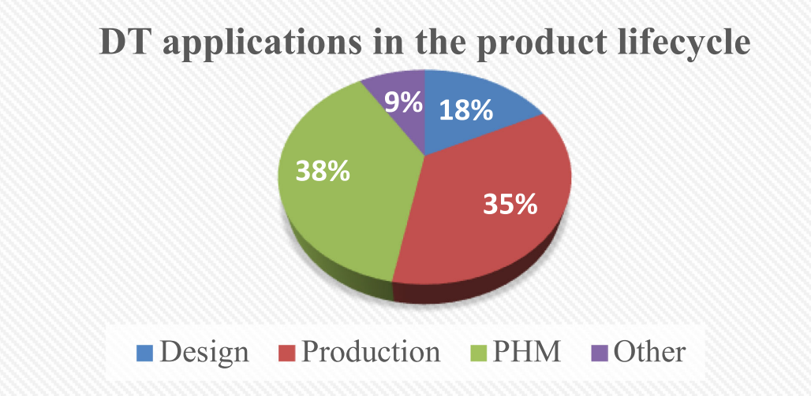

**Fig 2.2:** DT applications

**3.3 Digital Twin examples in practice**

**3.3.1 Digital Twin technology on city infrastructure:**

To improve the transportation and travel systems in New York City, the government decided to build a digital replica of the city itself. Having data on the average deterioration rate of a road in one of the busiest streets of the city, they are able to make safe predictions.

**3.3.2 Digital Twin is used for aerospace engine monitoring:** By creating a digital twin of an aircraft’s engine, pilots will have the ability to monitor engine health and progress the simulation 10 hours at a time (during a flight) in order to see if the potential risk of the engine experiencing a fatal failure in the near future.

**3.3.3 Digital Twin is implemented in the Germany rail network by nvidia**

**3.4 ADVANTAGES & DISADVANTAGES**

**3.4.1 Advantages**

**Comparison of digital vs physical product**

Comparing the digital and physical product becomes easier as the twin model tracks the progress of the physical product development directly.

**Performance monitoring**

Tracking the state of the physical product under the development helps to monitor the performance.

**Improved productivity:**

By giving the virtual experience of the product in the initial stages before the actual launch of product and improving the performance of the product according to the needs and requirements of the customer

**Increased reliability**

Products become long lasting because of improving performance of the product by handling virtual twin to the customer and making them experience the product and getting the feedback and implementing them accordingly.

**Performance tuning**

Improved product quality, enhanced insight into the performance of your products, multiple real-time applications and environments.

**Customer support**

Improved customer service as customers can remotely configuring customized products.

### **Data-backed financial decision-making**

A virtual representation of a physical object can integrate financial data, such as the cost of materials and labour.

**3.4.2 DISADVANTAGES**

**Compatibility challenges**

It mainly addresses challenges on technologies of sensors, communication, database and data processing. It becomes a big challenge in establishing compatibility between processes involved.

**Inconsistencies**

Inconsistences between models and entities appear. We need to choose models and entities which are consistent and support each other in their working conditions in creating digital twin.

**Handling data**

Integrate and converge the increasing data is a challenge. Handling large amounts of data coming from sensors and others physical devices seems to be a difficult task. We need to maintain large data storage to maintain and process the data accordingly.

**Security**

Security is another focus that ensures the normal operation of physical and virtual spaces. As we use many models and entities in designing digital twins, we face many security related issues.

**Chapter 4**

**Conclusion and Future Scope**

**4.1 Conclusion**

In recent years, there has been an unexpected progress in the technologies and capabilities of both the physical product and virtual product, the Digital Twin. Digital twins will evolve from concept to reality for nearly everything—everyone, every service, and every network. Digital twin usage is being driven through the rise of IoT designed sensors with the future of both going hands in hand. Sensors are able to deliver the data on how an object is operated and its reaction to the environment while implementing digital twins can improve analysis, condition simulation, operations, and value.

Al is becoming a component within Digital Twins and exploring where these algorithms can be applied is another avenue of open research. The effects of AI combined with Digital Twin are topics amongst the publications but on a small scale. The exciting and inevitable future research will explore scaling up smaller successful Digital Twin and AI projects. An important finding is the lack of standardization and misconceptions with definitions for Digital Twins. Addressing the challenges with standardization ensures future developments are actually Digital Twins and not wrongly defined concepts.

Product and business owners can realize the benefits of creating the virtual replica of their assets. A digital twin reduces cost and tends to increase market offers of high-quality products that benefit customers.

Despite the rapid growth, DT remains a rapidly evolving concept. Many pressing issues should be addressed to enhance its viability in practice. For example, a unified DT modeling method is critically needed. In that regard, this paper can guide more researchers to address the future directions of the DT research and application

The world's current technological development poses some limitations to the possibilities presented in this paper. However, in recent years, the trend of virtual reality has been set off in the internet industry, the concept of Metaverse has been proposed, and immersive virtual reality games have become its first application scenario. The idea of the Metaverse was inspired by the concept of the digital twin. As a key tool for digital transformation, the digital twin should meet the needs of the fast and dynamic transformation of human society and economy in the coming era and help realize a smart society.

**4.2 Future Scope**

It’s estimated that in the next few years billions of things will be represented by either digital twins, software models, and physical systems. It’s predicted that digital twins will be utilized by half of the large industrial companies and approximately 21 billion digitally connected sensors by 2020, which could potentially save billions in maintenance repair and operation. It’s also predicted by 2020 that up to 60% of manufacturers will monitor product performance and quality through using digital twins. Up to 60% of global companies will also use digital twins to deliver better customer service experiences. With the significance of digital twins evident, potential growth and use could be in effect for billions of years in the future.

As more companies use digital twins to build products, they can start building up entire ecosystems. Products can react in a virtual environment, giving real-time data to help develop future internet of things (IoT) products and more. Sectors that benefits from Digital twin technology are aerospace, defence, heavy machinery, automotive, consumer goods and electronic’s, power & energy etc.As per estimates, the market for digital twin is set to grow at a rate of more than 30% per year from 2020 till 2025 as an increase in demand for IoT and cloud-based platforms.

**References**

* N. Mohammadi and J. E. Taylor, “Smart city digital twins,” in 2017 IEEE Symposium Series on Computational Intelligence (SSCI), (Honolulu, HI), pp. 1–5, IEEE, Nov. 2017.
* N. Mohammadi and J. E. Taylor, “Smart city digital twins,” in 2017 IEEE Symposium Series on Computational Intelligence (SSCI), (Honolulu, HI), pp. 1–5, IEEE, Nov. 2017.
* Y. Zheng, S. Yang, and H. Cheng, “An application framework of digital twin and its case study,” Journal of Ambient Intelligence and Humanized Computing, vol. 10, pp. 1141–1153, June 2018.
* Q. Min, Y. Lu, Z. Liu, C. Su, and B. Wang, “Machine Learning based Digital Twin Framework for Production Optimization in Petrochemical Industry,” International Journal of Information Management, May 2019.
* Bilberg and A. A. Malik, “Digital twin driven human–robot collaborative assembly,” CIRP Annals, Apr. 2019
* C. Mandolla, A. M. Petruzzelli, G. Percoco, and A. Urbinati, “Building a digital twin for additive manufacturing through the exploitation of blockchain: A case analysis of the aircraft industry,” Computers in Industry, vol. 109, pp. 134–152, Aug. 2019.
* C. Mandolla, A. M. Petruzzelli, G. Percoco, and A. Urbinati, “Building a digital twin for additive manufacturing through the exploitation of blockchain: A case analysis of the aircraft industry,” Computers in Industry, vol. 109, pp. 134–152, Aug. 2019.
* E. J. Tuegel, “The airframe digital twin some challenges to realization,” in Proc. 53rd AIAA/ASME/ASCE/AHS/ASC Struct. Struct. Dyn. Mater. Conf., Honolulu, HI, USA, 2012, Art no. 1812
* <https://bernardmarr.com/default.asp?contentID=1870>
* <https://www.ge.com/digital/applications/digital-twin>
* <https://www.mathworks.com/discovery/digital-twin.html>
* <https://www.nvidia.com/en-in/omniverse/solutions/digital-twins/>